**BLOCKCHAIN, CRYPTOCURRENCY AND REAL ESTATE:**

**THE CURRENT SITUATION AND PROSPECTS FOR THE NEXT 5 YEARS**

By

Robert A. Simons, Ph.D.

Levin College of Urban Affairs, Cleveland State University

[r.simons@csuohio.edu](mailto:r.simons@csuohio.edu)

and

Samuel T. Simons

School of Business, University of Maryland, College Park

[massnomis@gmail.com](mailto:massnomis@gmail.com)

A paper presented at the Annual meeting of the American Real Estate Society,

Noplace, Zoomland March 2021.

ABSTRACT

Blockchain technology is a platform for transactions and investment. It includes Crypto currencies, of which there are dozens of investment vehicles, of which Bitcoin and Ethereum are the best known. Crypto is an emerging asset class, and offers some portfolio diversification benefits, as well as attractive rates of return, subject to “translation” or conversion back into underlying currencies like the US dollar. Blockchain allows ease of access and transparency, but also provides a cloak of anonymity, which may be incompatible with owning real estate, which generally has ownership and transactions as public records.

This paper provides a brief primer on the intersection of blockchain, cryptocurrencies and real property, and reviews the various ways that these emerging technologies and instruments are used in real estate investment today. We investigate a few blockchain-oriented investment platforms, including RealT, and report on their business model and customer-servicing interface. We look ahead to ponder future directions over the next 5 years where the best qualities of cryptocurrency and real estate overlap and may form a robust and sustainable investment environment.

**INTRODUCTION**

Bitcoin’s meteoric rise is well known but it is one of many cryptocurrencies, which is in part subsumed under blockchain technology. These have achieved prominence but are still highly controversial: depending on whom you talk to, blockchain and cryptocurrency either herald a revolutionary new approach to commerce or raise the specter of rampant speculation and corruption. Nevertheless, these innovations have made massive strides toward mainstream adoption. Major firms such as J.P. Morgan, Facebook (Libra? -check, stalled) and Alibaba have launched stablecoins (define) to allow seamless digital payments and central banks the world over is considering the tokenization of their fiat currencies. When applied to the appropriate applications, blockchain technology has proven its ability to deliver concrete advantages such as security, anonymity and transparency over traditional system management systems. We address how blockchain or cryptocurrencies (crypto), or both, are compatible with ownership of real estate in the US. What models exist, and which are likely to emerge soon? We focus on tokenization (securitization) of real estate, and how it can be originated, brought under a blockchain management system, provide returns to investors yet also provide scalable returns to property originators (owners of housing rental units) and blockchain management companies. We also look at potential social benefits to the communities that host clusters of these properties.

The real estate market is a prime target for blockchain because it can be managed publicly, even though individual ownership units are anonymous. Crypto’s disruptive potential is primarily as a very fast-growing medium of exchange that does appear to offer some potential tax advantages, and it (what?) sports a wealth of public information that is normally publicly accessible, relies on clearly defined contracts to complete transactions, and is highly illiquid. In this context, the integrity-protected data storage and process transparency offered by blockchain technology is a perfect fit for the real estate industry, while crypto is more of a sidebar.

**BLOCKCHAIN OVERVIEW**

The Blockchain is a set of separate computers that work together to maintain a ledger, or list of transactions. It can do whatever a regular computer can do, albeit slower, but more secure. Bitcoin, built on the first blockchain is essentially a numbered bank account, but all transactions are publicly broadcasted. Ethereum, the largest blockchain, allows for users to send executable code along with transactions. These are called “Smart Contracts” and allow for programable money and assets. Everything that has been sent is irreversible and permanent. Here is the timeline for blockchain development, coterminous with bitcoin, the most visible and highly capitalized cryptocurrency.

CRYPTOCURRENCIES OVERVIEW

Bitcoin and Ethereum are two of the most well publicized crypto currencies, but there are dozens of others Here are some common misconceptions:

* + Bitcoin is anonymous.
  + Bitcoin has no intrinsic value.
  + Crypto is used to evade taxes.
  + For every dollar in Bitcoin laundered, $800 in American cash is laundered.
  + Crypto currencies are too volatile (compared to what -consider the stock market or forex markets lately, or derivative markets (options, futures)

Exbibit 1 : Timeline of blockchain development:

SMART CONTRACT OVERVIEW

Blockchain finance, a new implementation of Distributed ledger technology has emerged as one of the biggest innovations in finance of the century. This technology relies on what are called “Smart Contracts”. Smart contracts can be thought as a lawyer sitting inside a vending machine (Schär). This essential building block allows funds to be transferred, spent, lent or without manual intervention. By coding a smart contract, the user defines the parameters in which funds can be used. Simple smart contracts can be used to facilitate OTC trades between two parties, can allow timeclocks on funds, and can even facilitate complex trading and lending markets.

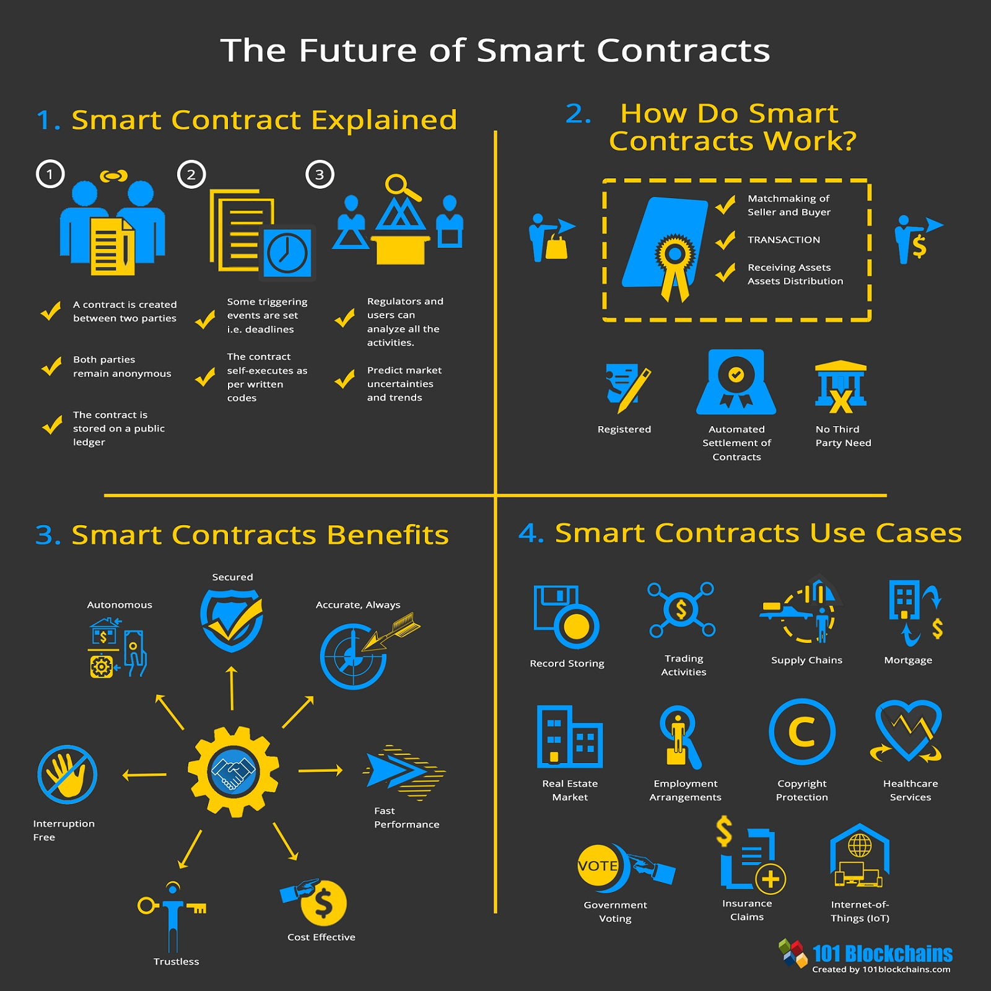

Two worlds of emerging finance

Out of the ashes of bitcoin a new financial system has arisen, based on blockchain technology and decentralization.

The traditional real estate investment platform at least publicly is the REIT. The real estate investment trust is a securitization of a real estate portfolio. Listed on many securities exchanges, the REIT has been well sought after by institutional and retail investors alike, to gain exposure towards real estate markets and their phenomenal cash flows.

Historically speaking the REIT has hit it out of the park. Because the system and the fund has the ability to be listed on a public stock exchange, the liquidity for any given fund is astronomical compared to any private system. a stock exchange, specifically the NYSE can process hundreds of thousands of transactions a second, creating a technological race to the bottom, where firms compete on how fast they can fill orders, measured in the millisecond. For example, Goldman Sachs has spent hundreds of millions of dollars in infrastructure investment to shave 21 milliseconds off their transaction speeds (CNBC).

Even non-brokers and traders have utilized the fast transaction speeds that the information age has brough upon us, visa, for example relies on a network that can process 50k TPS, allowing for secure and quick payment channels between millions of consumers and merchants, all seamlessly and in the background.

Banks built on wires and ACH, swift are “backed by the government” has its good and bad, but how does it compare to new technologies?

Below is a table comparing the two classes of financial technologies.

|  |  |
| --- | --- |
| Decentralized finance | Cefi  Centralized Finance (Includes centralized bitcoin exchanges, clearing houses, banks and stock exchanges. |
| Tokenization (Will define Later on) | Securitization (Will define Later on) |
| Censorship resistant | Possible single point for failure |
| Can leverage multiple exchanges simultaneously | Backed up by government |
| Arbitrage available to all, more efficient markets | Can handle more transactions |
| Distributed ledger, harder to fail as a whole | Visa can do 50,000 transactions per second |
| Inexpensive startup costs | High startup costs |
| Divisible, Fractional | Singular codebase or clearing house |

Securitization and tokenization

|  |  |
| --- | --- |
|  | Securitization |
| Tokenization is an act from an asset owner placing their asset on a blockchain, so that anyone may interact as they please, from any system or computer | Securitization is an act of a centralized exchange placing a real-world asset on their computers and or ledger, so that others may trade within their system |
| Provable, “public” ownership | On a singular exchange, high cost of transfer |
| Move between platforms and contracts | Locked within that platform |
| Many use cases  Utility, payment, debt, equity, ownership deed | Comes complaint, as exchange does all the work |
| Cheap to issue | Expensive to issue |

To understand how finance on the blockchain works, we must first delve into how value, i.e. USD, is stored on this system. We all have heard of how many digital assets like bitcoin are incredibly volatile and backed by little to inherent value. Outside of the cryptocurrency enthusiasts, there exist a small handful of well-established and regulated firms who have taken it upon themselves to bring stability towards the digital asset market. The products they have brought forth are referred to as stablecoins. A stablecoin, at least for the ones applicable to real estate can be backed by fiat currencies or by commodities.

For example, Paxos, a New York State-chartered trust company regulated by the New York State Department of Financial Services, has created two monumental products, Paxos Standard and Pax Gold (Cascarilla). Pax Gold was created to reduce the costs associated with owning and storing gold. Paxos bought a fixed supply of gold and sold the corresponding equity on digital exchanges. Paxos created only the number of shares as there were ounces in storage and the price was pegged at 1 PAXG = 1 oz of gold. Whatever the market price for gold is at any given time will be the price listed on the digital asset exchanges. Unlike greenbacks today, holders of the digital asset can redeem their shares for physical gold through Paxos, at any given time. Paxos, essentially an agent of the State of New York has been able to reduce the number of physical transactions of gold and has created a more secure and efficient storage process for the commodity.

Gold is simpler, and single commodity exchange traded funds have existed for a long time. Never had there ever been the demand for digital money. Yes, money is mostly digital at this time, but just like Pax Gold, digital money in banks was created to be withdrawn. Paxos took advantage of its money transmitter license and its earlier successes to bring digital dollars to the blockchain. The new service, called Paxos Standard, was a new, dollar backed, digital currency. This same service allowed for the digital ownership of fiat backed digital assets to be redeemed at Paxos immediately, just like a bank. Although it has many similarities with a bank, the one that sticks out the most is its lack of a fractional reserve model. For every dollar issued in value on the blockchain, there is a correlating dollar in the bank account held by Paxos. This means that at any given time given a bank run, Paxos would be able to service its liquidity with no problem.

.

While in traditional markets only big players can take advantage of arbitrage and market making opportunities, Defi allows for the average people to collectively pool capital and algorithmically become a unified and profitable market maker (Egorov).

In a typical order book market, there is what we call a bid and ask. This means the highest one is willing to pay for an asset, and the least one is willing to sell for. The distance between these two is called the spread. There inherently must be a distance between these two numbers, otherwise both orders would find each other and be filled. When a new player comes into the market, they may place a limit order at any given price, or they can have their order fill instantly with a market order. For someone who wants to make money off the market, they must position themselves on both the buying and selling side of the order book. This way, no matter what kind of order, buy or sell, limit or market, the “market maker” will profit the difference between their positions, since they buy for less than they sell.

While this sounds technically sound, this market making method has a few problems, one being its inequity.  It required a very large amount of capital, computer and programming resources and close connections to the exchange computer (Williams, Peterson). This is not something an individual with $20 dollars in the bank account can make money on.

Years later, blockchain developers created a system for the everyday man, one that does not require huge swaths of capital or immense technological capabilities. Meant to be able to provide liquidity to the everyday man this system does not facilitate order books (Adams). Those who want to make money off trading will provide liquidity to a pool. This means that many individuals put assets together into one non-custodial fund that others make trades with. The money is made by chagrin around a 0.3% fee, which is typically the spread in any liquid market.

On the trading side, the swap price is set up with what is called a price oracle, a decentralized technological function that aggregates several exchange prices. From here, one who wants to create an order, or a swap will “call” the current market price and trade with a liquidity pool. The swapper pays a small fee to make the trade and they go on their way.

Margin Investing

Now margin lending has been outside traditional banking for decades at this point, so the concept may not be fresh in everyone's mind. Let us say that you own one share of Apple stock. As a huge fan and a believer in the company's long-term performance, you do not wish to sell this asset anytime soon. So, your stockbroker introduces you to a man who does not think that Apple will perform well in the next few days. The man says to you, “I will pay you 5% APY to ‘borrow’ your security.” This man wants to short sell Apple, meaning he is going to sell the stock now and repurchase it later for cheaper. At the end of the period, he will return the stock to you with 5% yearly interest. You and the broker are protected by a margin, or collateral, a larger amount of liquid value held in the borrower’s portfolio. If Apple share price goes up, the borrower will have to add more collateral, or be forced to buy the stock back at a loss and forfeit his or her collateral.

On the blockchain, this margin lending system has been created without the need for a TTP. A system called “Compound Finance” is a great example of this decentralized financial ecosystem (Leshner). Like margin lending, there are two parties at play, one going long, and the other going short. However, there is no broker, as this is done with pre-audited code called smart contracts. One party will post collateral, typically Ether, a popular cryptocurrency, and ask for a loan worth roughly 50% of the collateral value. The APY typically fluctuates with supply and demand, but it is usually around 10% APY. Another party will provide stablecoins to the borrower and collect the interest payment.

The collateral is managed by a system of computers known as keepers. They make sure that the collateral value is safe and will contact the borrower if there is a risk of liquidation. If there is ever a loan collateral that is reaching dangerous values, any individual may come in and purchase the debt. The purchaser is required to post the margin and in return they may redeem the underlying value.

So why would someone ever do this? Well unlike margin lending, there is no one going short. Because the other asset is a stablecoin, considered a risk neutral position, there is only one person going long. If someone really believes in Ether, they may be able to almost double their position by using this protocol. Now, if the price goes up, they will easily be able to pay from their profits. If it goes down, then the lender will benefit. Either way for the lender, this is a win-win.

As of July 30, 2020, there is around $2.7 billion dollars locked into these protocols, up over 100% the last few months. (Late February 2021, 35.14 Billion.) There have been many recent developments in this technology and a handful of capital firms and institutional investors heavily investing. For someone who is distrustful of banks and embracing the future, it is the place to be financially.

**REAL ESTATE AS A POTENTIAL INVESTMENT**

Real estate is a physical asset, usually funded with debt, or otherwise with OPM (other people’s money).  It is usually illiquid, but single-family houses are relatively interchangeable, (substitutes and comparable easily found). Multifamily and commercial properties are more unique. The owner must own the entire unit, so it has very low divisibility.

The equity structure of real estate can have many levels. Typical deals are funded with a permanent first mortgage from a large bank loan, or pension fund, and many have a second mortgage with a higher rate of interest than the first mortgage.  On the equity side, limited partner (senior) equity gets paid before and developer (primary power, and general partner) equity, which is subordinated to all debt and equity, but also gets a higher return.  The limited partner equity tranche could potentially fit with a crowdfunded equity source. However, as we will shortly demonstrate, the model used by at least one blockchain model has no debt at all: the entire property value is tokenized (securitized) into bite-sized $50 units, resulting in excellent divisibility.

There are several types of real estate investments available on the blockchain. Many, if not all legitimate investments require institutional investment status. This is because they are all heavily regulated by the US Securities and Exchange Commission (SEC) or other government entities. If investments are on the blockchain, the issuing corporations could potentially save money on public exchanges listing fees. In addition, these markets are potentially more liquid because of the platform they are on. For non-institutional investors, to ensure security and regulatory legality, trades can only be made to approved persons or addresses, such as accredited investors.

Blockchain platforms can now obtain real estate to be listed, securitize it, and make it available to investors in divisible bites, and maintain an anonymous, transparent and instantaneous payment system. One example is a company called “RealT” has done this. Restricted to accredited investors and issued on the Ethereum blockchain, RealT has brought tokenized real estate investment units to individual investors. For each listing, a management company (typically the listing developer/originator) is retained to do maintenance, collect rent, and take a modest fee while the entire equity of the property is sold off for stablecoins on the blockchain. Once rent is collected, it is tokenized and sent proportionately to equity holders. This platform makes accessing real estate investing simple and profitable.

**RealT CASE STUDY**

Real T is one of several known companies marketing fractional tokenized ownership of residential properties on the www. Transactions are managed/maintained on the Ethereum blockchain. Although you can pay with crypto currency, USD is the common currency. Thus, this case study focuses on the blockchain, rather than crypto side of innovation.

**Demand side: investors**

On the demand side, investors must be high-income/net worth qualified investors as per SEC rules. Once vetted and admitted, investors can purchase property shares as they become available in the primary (similar to an ICO) market. There is also a secondary market for shares that can be bought and sold after origination, but this is the focus on a later paper. Properties are offered to both US (Regulation C) and foreign investors (Regulation S) in separate tranches. We consider them interchangeable for the purpose of this case study. Investors buy “units” of about $50 each, which is the minimum stake, If the typical property is worth say, $65,000, then about 1,300 units would be available. Each investment unit offers a stated return, say 11%, payable monthly. Investors can buy as many units as they like[1]. All rent distributions, ownership and other transaction-related activity is transparently available for viewing on the blockchain, and rent payments are direct-deposited via smart contracts[2].

**Supply side: RealT and originators/developers**

On the supply side, RealT is a two-year-old start up with about 50 properties in its nascent portfolio. Its main function is to provide a bridge between independent originator/developer who list their properties on RealT’s blockchain platform, thus enabling investors to access them and buy tokenized ownership equity units. The typical property listed by a developer is a single-family house in good condition in an inner-city neighborhood (mostly in Detroit, but a few in Cleveland, Akron and Rochester NY). Because they can be bought very cheaply (supply exceeds demand in central city markets), many are in good physical condition and with modest repairs and upgrades and can be brought into the RealT portfolio as independent LLCs as fully rented and generating returns in excess of 10%. The property transactions appear twice in the public record a few weeks or months apart: once as the originator/developer acquires the house off the market at a local price, and a second time when it’s put into the RealT portfolio at its higher, securitized price. While these homes can offer substantial positive cash flow, in these markets long term appreciation is likely negligible. Once in the RealT portfolio, tenants pay rent to the LLC which has a property management entity (likely the developer) that manages rent collection and deals with maintenance issues. These net funds flow onto the RealT blockchain and are distributed to unit holders as per the smart contract. Exhibit 3 below shows the ownership structure and cash flow stream.

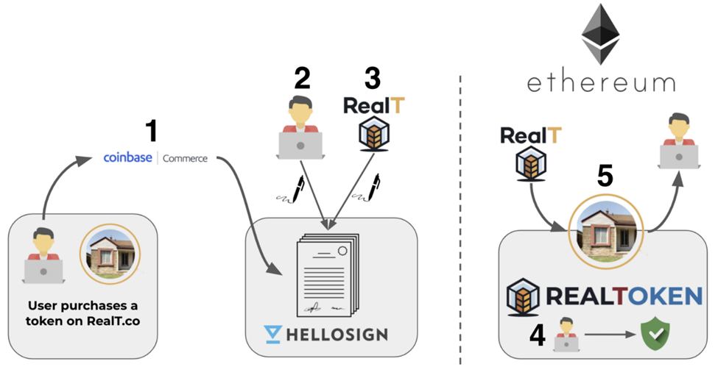

Exhibit 3: RealT System Ownership Flowchart

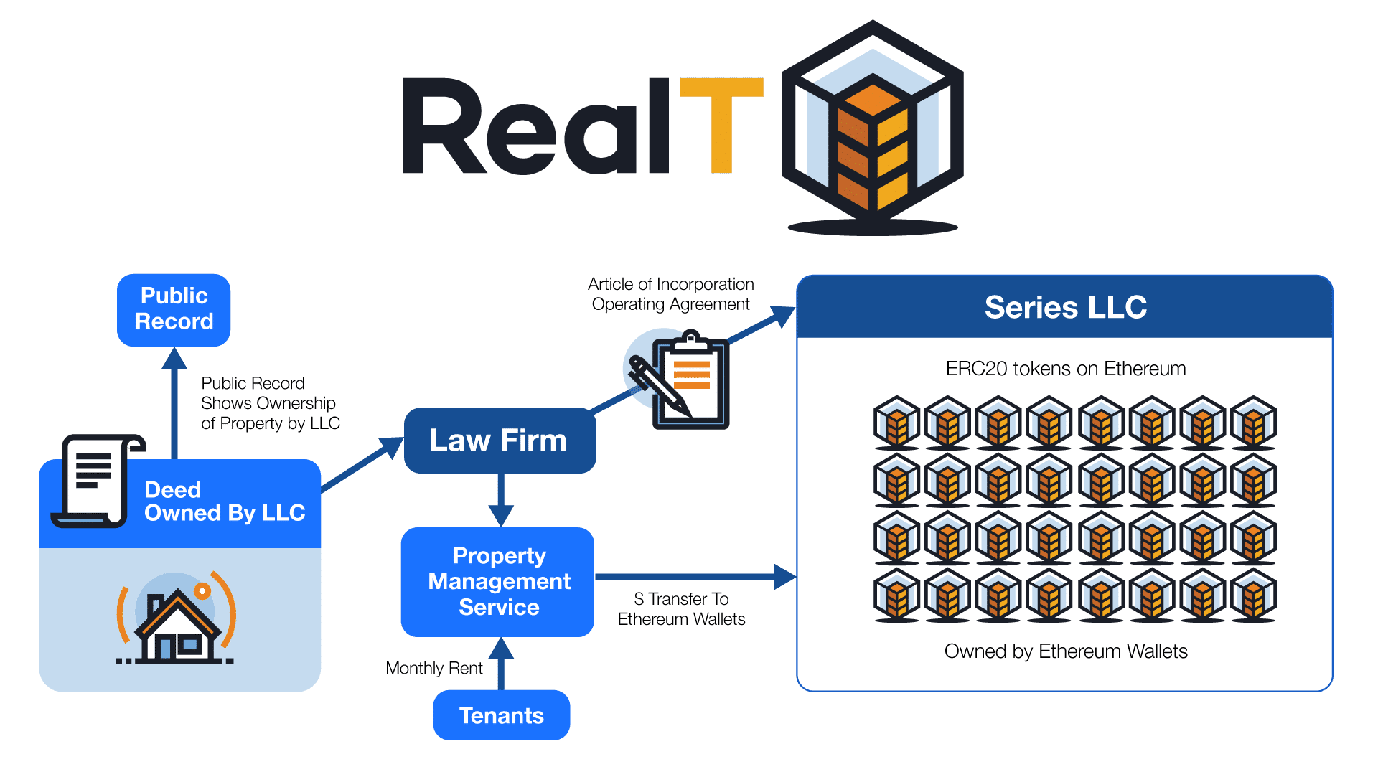

Source RealT 2021

**The RealT portfolio**

We started tracking Real T in late November 2020. At that time, there were 19 properties in the inventory. This grew to 35 properties by January 20, 2021. By February 10, 2011 there were 43 properties in there, with several being added every week or two. Most of the properties are in Detroit, Michigan. Exhibit 4 shows the profile of the current RealT portfolio, broken down into the Detroit single family/doubles and other (a few apartment buildings and detached houses outside Detroit).

Exbibit 4: February 2021 RealT Listed Property Portfolio



The portfolio is pretty typical of an inner-city market: properties often have 3 bedrooms, 1.5 baths, about 1,300 square feet, are over 80 years old, and generate gross monthly rents of $870, about $0.75/SF/month. The entire tokenized price is about $66,000, and there are about 1,300 tokens priced at $53/token offered to investors. These tokens offer returns above 10%. Interesting enough, over half of the tenants in these rentals are Section 8, which could have major upside implications for stable cash flow, low turnover and cash flow stability. The properties outside Detroit are small apartment buildings, (average of 10 units per property), with average unit size of about 800SF, with similar rent and tenant profiles. Those deals had a tokenized value of about $430,000 and offered 5,600 tokens (average cost $85) per property to investors, at slightly lower, but still healthy returns.

**The buy and getting the property into the Real T inventory**

There are two parts to this analysis. First is the buy and listing the property, followed by its ongoing cash flows offered to investors. On the buy, the typical property had a RealT syndication value of about $65,000. However, cross-checking the property on Zillow showed that the Zestimate was about half that, or $35,000. The same property would likely have the same rent on Zillow and in the RealT offering statement of $850 per month. Thus, it appears there is substantial upside in listing the property on RealT (basically flipping it), and this is corroborated by the following assumptions. Even after allowing for $10,000 for repairs and upgrades, marketing and financing costs, a one-time Real T syndication/tokenization fee of 5%, the potential unleveraged profit margin is about 40%, a nice return. This is detailed later in the top left side of Exhibit 6.

Once the property is listed, rents from a fully-occupied property support a projected rate of return, after property taxes, maintenance, marketing, a vacancy allowance, and a Real T service fee of 2%, and a management fee of 8%, that likely accrues to the originator/developer[3]. The available net cash flow of $7,300/year is distributed to token owners in proportion of their ownership in the property. See Exhibit 5.

Exhibit 5: Single Unit Cash flow Example offered to Investors



Source: RealT

**Scalability of the RealT model**

Having set the basic assumptions, we now examine how scalable this model is for both the originator/developer and RealT the blockchain company. For the originator/developer, we assume they operate in a metro area they know well. We assume they can select appropriate houses or apartment buildings, buy properties at or below market prices, and can rehab units, obtain financing if needed, market the units and fill them, and also do the property management. Each unit should take three months or less to acquire, do the physical rehab work, rent up and place on the blockchain. We assume the originator/developer desires to grow the number of properties on RealT to achieve cash flow and some economies of scale in property management.

Based on these building blocks, Exhibit 6 shows the scalability of the RealT model. We examine returns to the originator/developer on the left side, and the top left quadrant restates material presented above for a single unit, and expands it for 10, 25 and 100 units. We address both cash flows for the original placement/development, and ongoing cash flows from management. Note that by the time the originator/developer places the property on the blockchain, they have cashed out, and unless they own tokens, they have no money left riding on the property, just the opportunity to manage the unit for a fee. From the developer’s perspective, most of the money is in listing the properties rather than ongoing management. Each property has a large profit (estimated at 40% using these assumptions) for “flipping” the property onto the blockchain. For management, they’d need 100 units to net $50,000 a year on those fees. The items in red show RealT’s take, both on origination, and for ongoing servicing.

On the right side of Exhibit 6, we show RealT’s earnings, at a larger scale since they are presumably doing this in numerous markets. Likewise, the bulk of their funds comes from the one-time-per-property listing/securitizing fee. At 1,000 units under management, the fees they’d make (over $3 million) looks like it could support a business nicely.

Finally, at the bottom of Exhibit 6 we combine these growth scenarios over a five-year ramp-up period for both the individual originator/developer. For the city-originator, we assume a steady increase to adding up to 30 new units a year onto the blockchain, also yielding a total of about 100 total units under management by year 5. The revenues do look sustainable, and could likely support a few employees, although the mix of revenues from origination rather than management stays quite high, at almost 90%. Further, net revenues from property management are only about $60,000 a year. To do “real” money (not RealT), the entrepreneur would likely have to grow faster than we show here. On the other hand, if originator/developers tokenize apartment buildings rather than houses, or if the houses are more expensive and can still generate adequate returns such that investors would buy the tokens, then the revenues would certainly increase.

From the perspective of RealT, we assume they can add five cities (each having an originator/developer performing similar to that shown on the left side panel) a year, up to a total of 30 urban markets within five years. That gives them 900 (single family sized) properties on the blockchain from all sources by year 5. Using these assumptions, they break $1 million by year four, and have a nice upward trajectory after that. If their originator/developers tokenize more expensive property and can still generate adequate returns such that investors would buy the tokens, then the revenues would certainly be higher.

Exhibit 6: Scalability of the RealT Model



**SECONDARY AND INDIRECT BENEFITS OF THE RealT PROGRAM**

Detroit is not alone. Cities like Cleveland, Buffalo, St. Louis have stable rents and declining asset values due in part to negative population growth. These markets can offer a high cash-on-cash return to real estate investment, and easily hit the 10% threshold attractive to online token investors. There are likely dozens of markets in the US where the RealT concept could be replicated, and in larger markets there could be room for more than one local originator/developer.

Since the typical Zillow market price of an asset in the RealT portfolio appears to be about half of its securitized price (but rents are about the same), there are a number of implications. First, obviously, there is a profit potential for the investor to acquire the property, get it fixed up and leased up, and flip it into the RealT online portfolio. The value-add here seems to be both the physical/rent-up, but also that securitizing it allows a way to find token investors that increase the asset price, and still produce 10%+ returns.

But bringing residential properties into the RealT portfolio also increases property values in the inner city: these sales are legal and registered with the local authorities, and appraisers can use them as comps in valuating nearby properties. Thus, this could swing the house price pendulum back toward higher values, larger mortgages, higher net worth for owners of inner-city residential property. This is a good thing[4]. Increasing inner city property values has been a thorny, even a vexing societal issue, and also directly affects wealth creation among African-Americans and other minorities (Perry, 2020, Chapter 2). Buying up real estate with interested capital partners could help redevelop neighborhoods, and add appreciation to property values. Perhaps investment in RealT could satisfy a Bank’s CRA (Community Reinvestment Act) requirements.

Another intriguing observation is the prevalence of Section 8 tenants in the RealT portfolio. This type of tenant tends to be very stable, so rental turnover is minimized, and the required property quality adds a sense of oversight and assurance that the property conditions are maintained. In a sense, RealT could be looked as a type of Section 8 secured portfolio, backed indirectly by the US government.

**CONCLUSIONS AND FUTURE RESEARCH**

Blockchain technology is a platform for transactions and investment. It includes Crypto currencies, of which there are dozens of investment vehicles, of which Bitcoin and Ethereum are the best known. Crypto is an emerging asset class, and offers some portfolio diversification benefits, as well as attractive rates of return, subject to “translation” or conversion back into underlying currencies like the US dollar. Blockchain allows ease of access and transparency, but also provides a cloak of anonymity, which may be incompatible with owning real estate, which generally has ownership and transactions as public records.

This paper has provided a primer on the intersection of blockchain, cryptocurrencies and real property, and reviews the various ways that these emerging technologies and instruments are used in real estate investment today. We did a case study of a blockchain-oriented investment platform called RealT. Their business model and customer-servicing interface appears to be sustainable for token buying investors, originator/developer partners that list and manage the properties, and for the parent company that provides a marketplace where properties are tokenized on the blockchain with smart contracts. We look ahead to ponder future directions over the next 5 years where the best qualities of cryptocurrency and real estate overlap and may form a robust and sustainable investment environment.

Some loose ends: We are not sure of exit strategy for owning these houses. Perhaps you just sell your tokens, maybe tenant can buy them, or one owner can accumulate tokens, likely at a reduced price, maybe after a non-payment event (say vacancy).

Also, rental property generates an annual depreciation allowance of 3.63% of the non-land part of the property. Not sure how this is allocated. Maybe after income tax time, I’ll find out since I own a few tokens in a Detroit RealT house.

Asset Pricing in real estate Zillow, potential for arbitrage, huge neighborhood upside in house prices.

Benefits of transparent blockchain investments: All transactions data are public

* + buying, selling, rent payments
  + Amounts and participants
  + Primary market, Secondary market
  + Large amounts of liquidity including Bid-Ask spread
  + Live secondary pricing data
  + Transparency in pricing assets
  + No money laundering
  + Dividends and liquidity
  + Transparency
  + Shareholders can place shares in escrow to be market makers
  + Still receive rental payments
  + Receive profits of bid ask spread
  + Must place both buy side and sell side orders
  + Automated Market Makers
  + Dividends are paid without ex-dividend date
  + Those who own at payment time receive payment
  + No weird price swing to calculate expected dividend
  + Secondary market liquidity

Future research includes secondary market for tokens, more volume on RealT, other similar firms, crating a token index, and watching to see within a few years if local house prices creep up. Finally more thought needs to be put into the apparent fact that RealT is essentially a Section 8 backed Security.

**REFERENCES**

Robert Leshner and Geoffrey Hayes. Compound: The Money Market Protocol. Feb. 2019. url: [https://compound.finance/documents/Compound. Whitepaper.pdf](https://compound.finance/documents/Compound.%20Whitepaper.pdf).

*Hayden Adams. Uniswap. url:* [*https://uniswap.org/docs/*](https://uniswap.org/docs/)

Perry, Andre. 2020. Know Your Price. Washington DC: Brookings Institution Press

Schär, Fabian & Schuler, Katrin & Wagner, Tobias. (2020). *Blockchain Vending Machine: A Smart Contract-Based Peer-to-Peer Marketplace for Physical Goods.*

*Vitalik Buterin et al. 2013. Ethereum white paper. GitHub repository (2013)*.

<https://www.coindesk.com/bloomberg-terminal-lists-ethereum-based-debt-instrument>

<https://withcadence.io/blog/>

<https://www.centre.io/usdc>

<https://www.paxos.com/paxgold/>

RealT. Legally Compliant Ownership of Tokenized Real Estate. White paper. <https://realt.co/education/> las accessed February 23, 2021.

<https://www.jpmorgan.com/commercial-banking/solutions/commercial-real-estate/community-development-banking/community-development-banking-faq>

<https://www.jpmorgan.com/commercial-banking/solutions/commercial-real-estate/community-development-banking/new-markets-tax-credit>

<https://www.policymap.com/2015/07/mapping-cra-eligibility/>

<https://dashboard.realt.ch/map>

<https://www.policymap.com/2015/07/mapping-cra-eligibility/>

https://www.cnbc.com/2019/08/01/goldman-spending-100-million-to-shave-milliseconds-off-stock-trades.html

1. Further, at least at this time, RealT offers some “guaranteed buyback” provisions, though it is unclear how sustainable these are in the long run.
2. The types of reports available to investors on ownership, distribution of cash flows and other items are remarkable and numerous. They are graph based, and show all the property’s expenditures, but everything is anonymous, as owner units are identified by numbers not by name. They are updated in real time and are remarkably transparent.
3. The RealT contract calls for a slightly lower cut, but also allows for additional management fee for distributing maintenance funds.
4. On the downside, if property values go up, so will property taxes, so some people will complain about that.